Please update any information that has changed since your last visit to our office.

Name: ________________________________________ DOB: ____________________
Address: _________________________________ City: ____________________ State: ____ Zip: ___________
Occupation: _______________________________ Phone: ________________________________
Emergency Contact: _________________________ Relationship: ________________ Phone: _______________
Email Address: _________________________________ How were you referred to us? _____________________
Primary Care Physician: _____________________________ May we contact them? Yes No
Current condition information:
When did your condition begin? _______________________________________________
Mark Areas of Pain on Figures Below
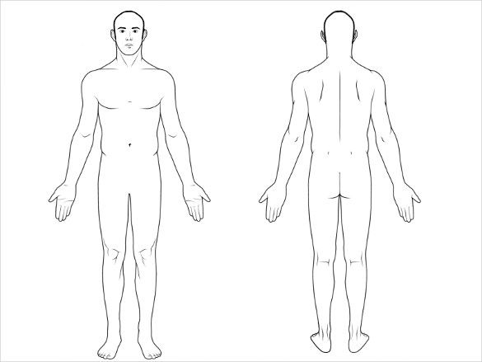
List chief symptoms in order of severity:
(1): _____________________________________
(2): _____________________________________
(3): _____________________________________
Have you had chiropractic care before? Yes No
Current Medications: ________________________________
__________________________________________________
Allergies: __________________________________________
Previous Surgeries: __________________________________________________________________________
Do you have a personal history of: Cancer Stroke High blood pressure
Other serious illnesses: _______________________________________________________________
Check all symptoms that apply to you:
□ Headache □ Tingling/numbness in arms/hands □ Chest Pain □ Unexplained weight loss
□ Neck Pain/Stiffness □ Tingling/numbness in legs/toes □ Knee Pain □ Fatigue
□ Back Pain/Stiffness □ Loss of balance/dizziness □ Hip Pain □ Night Sweats
□ Shoulder Pain □ Shortness of breath □ Fever □ Blood in Urine
Other _____________________________________________ □ Night Pain □ Pain unrelieved by rest

Do you have a Pacemaker? Yes No Do you smoke? Yes No

For Women: Are you Pregnant? Yes No

Health Insurance
Policyholder Name ______________________________________Date of Birth _____________________________

Workers Compensation
Is your condition due to an Employment Related Injury? Yes No Have you reported it? Yes No
Date of accident _________________________________
Supervisor ______________________________________ Supervisor # __________________________________
Auto Accident
Is your condition due to Automobile Accident? Yes No Date of accident __________________________
Auto Accident Insurance Name _____________________ Claim # _______________________________________
Adjuster Name __________________________________ Phone #_______________________________________
Attorney Name __________________________________ Phone #_______________________________________
INSURANCE INFORMATION, CONSENT OF PROFESSIONAL SERVICES AND RELEASE OF INFORMATION
I understand and agree that health and accident insurance policies are an arrangement between an insurance carrier and myself. Furthermore, I understand that this office will prepare any necessary reports and forms to assist me in making collection from the insurance company and that any amount authorized to be paid directly to this office will be credited to my account on receipt. However, I clearly understand and agree that all services rendered to me are changed directly to me and that I am personally responsible for payment. I also understand if I suspend or terminate my care and treatment, any fees for professional services rendered to me will be immediately due and payable.
I hereby authorize Dr. Martin, Dr. Hobbs, and their affiliated providers to administer treatment, physical examination, X-ray studies, laboratory procedures, chiropractic care, physical therapy, or any clinic services that they deem necessary in my case; I do hereby give my consent for the performance of conservative non-surgical treatment, including, but not limited to manipulation, physical therapy modalities, cupping therapy, soft tissue massage and therapeutic exercises. I am aware there are possible risks and complications associated with these procedures, ranging from soreness to stroke. I understand there is no certainty that I will achieve benefits and acknowledge that no guarantee has been made regarding the outcome of these procedures. I am aware there are alternatives to these procedures, including medication and/or surgery. I further authorize them to disclose all or any part of my (patient’s) record to any person or corporation which is or may be liable under a contract to the clinic or to the patient or a family member or employer of the patient for all or part of the clinic’s charge, including, and not limited to hospital or medical services companies, insurance companies, workers compensation carriers, welfare funds, or the patient’s employer.
I understand that if an insurance company initially pays for my treatment and later requests reimbursement from Medina Family Chiropractic LLC for any reason, I will be responsible for payment of my entire outstanding balance.
Patient’s or Guardian’s Signature _________________________________________Date ______________________
CONSENT TO TREAT A MINOR
I (we) being the parent, guardian or custodian of the minor being _______________________________, age ______,
do hereby authorize, request & direct Medina Family Chiropractic, it’s doctors and staff to perform examinations, diagnostic x-rays, laboratory tests, and any treatment that in their judgment, is deemed advisable or required.
It is the understanding of the undersigned that the physicians and their staff will have full authority from me as legal parent/guardian to continue with examinations, diagnostic tests, and treatments as will be needed while said minor shown above is under care in this office until legal age is attained.
As legal parent/guardian, I realize full responsibility for all charges and payments due.
Parent/Guardian or Custodian Signature ___________________________________ Date Signed ___________________

